**Practical No-1**

**Aim:- Draw E-R diagram and convert entities and relationships to table.**

**Q.1 Construct ER Diagram for car insurance company whose customers owns one or more cars each. Each car has associated with it zero or any number of accidents. (Assume all mapping cardinalities exits)**

Step 1:- Identify all entities

1. Car b) customer c) accidents d) insurance_company

Step 2:- Identify all attributes

1. Car- owner_name, car_model, car_number

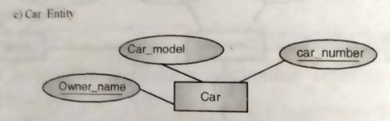

1. Customer- customer_name, customer_id, customer_address, customer_dob,cutomer_ph

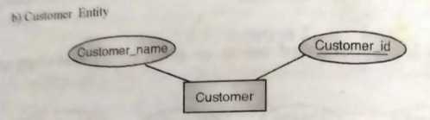

1. Accidents- car_number, acc_id

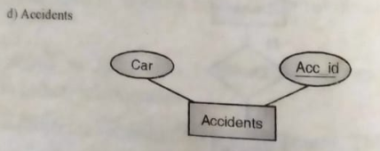

1. Insurance_company- company_id, company_name, company_address

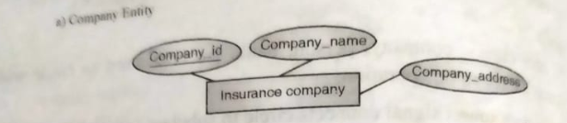

Step 3:- Identify all relationship

1. Car insurance company has a set of customer

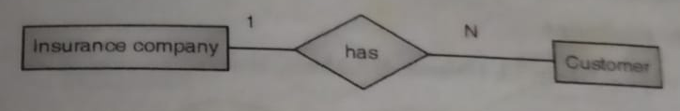

1. Customer owns one or more car

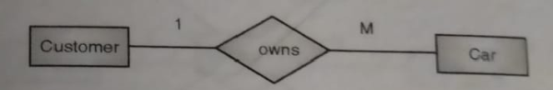

1. Each car associated with zero or any number of accidents

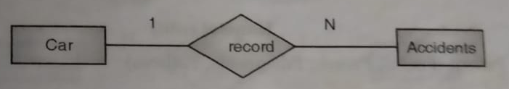

Step 4:- Construct ER diagram by merging all above relationship.

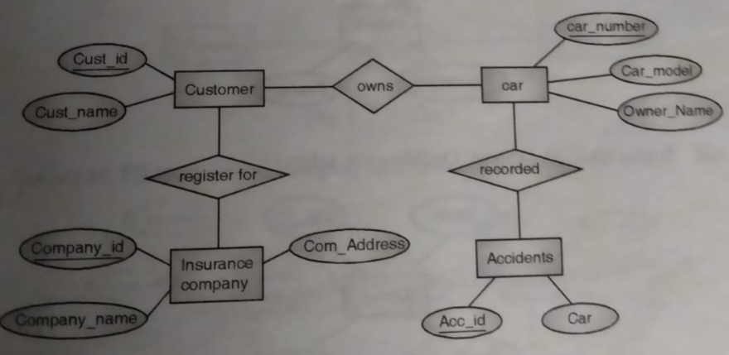

**Q.2 Consider following databases and draw ER diagram and convert entities and relationships to relation table for a given scenario.**

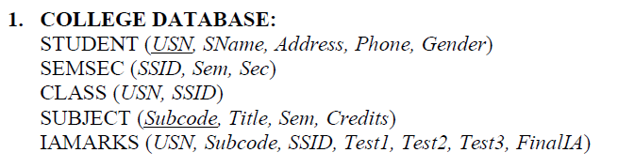

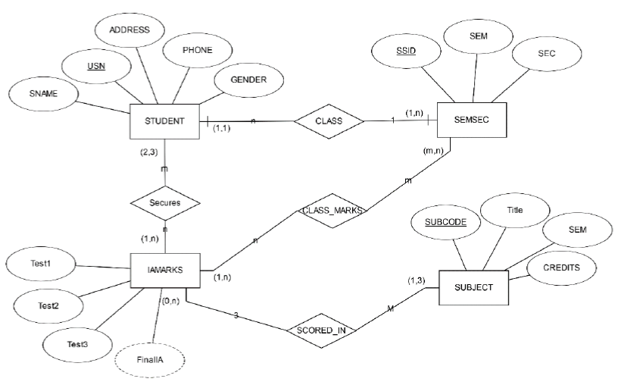

**Q.3 Consider following databases and draw ER diagram and convert entities and relationships to relation table for a given scenario.**

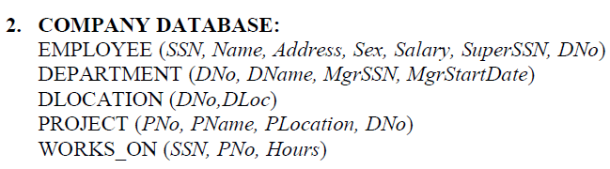

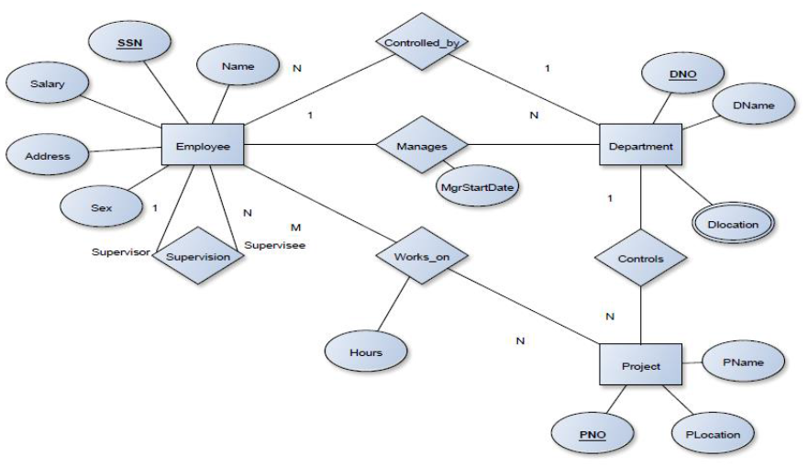

**Q.4 Convert following ERD into its table form.**

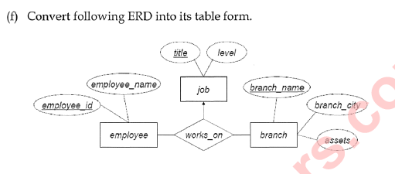

Answer:-

Table name:-

1. Job:- title(primary key), level
2. Employee:- employee_id(primary key), employee_name
3. Branch:- branch_name(primary key), branch city, assets

|  |  |
| --- | --- |
| Job | |
| Title | varchar(20), primary kay |
| Level | varchar(5) |

|  |  |
| --- | --- |
| Employee | |
| Employee_id | varchar(20), primary kay |
| Employee_name | char(10) |

|  |  |
| --- | --- |
| Branch | |
| Branch_name | char(20), primary kay |
| Branch_city | char(15) |
| Assets | Int |